**PROBLEM:**

Despite the fact that Indian law prohibits individuals and organisations from using electric fences without authorization from authorities, they are widely used in India. Many dangers have been recorded in the nation as a result of different factors such as energiser malfunction, excess current, and over voltages. Furthermore, electric fences are subject to numerous physical defects such as breakage, short circuit, overloading, and so on.

Monitoring the fence system by keeping track of voltage, current pulse length, and other parameters is a time-consuming duty for an employee. As a result, effective system operation is difficult to assure, and in certain circumstances, the entire system fails to perform its duties in critical situations.

**MARKET SURVEY:**

1. Fence Voltage Alarm System by Crown Power Fencing Systems, Tamil Nadu

*Features:*

* Generates an alarm when array is cut, shorted or grounded
* Generates alarm also when the voltage falls below pre-set value
* Remote Turn ON and Turn OFF via GSM
* Fault warning messages via GSM
* 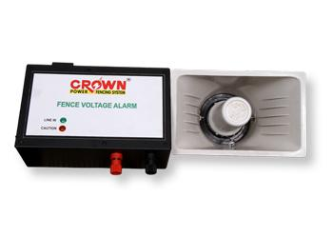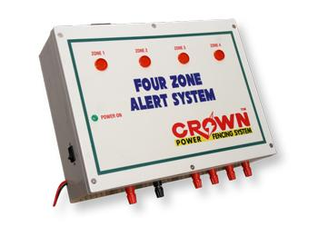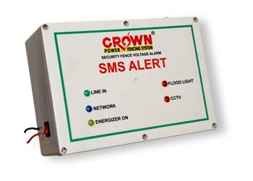Customised for multiple fences simultaneously.

1. Altima fence by Altima Security Technologies, New Delhi

*Features:*

* Makes alarm when climbing, cutting and shorting of wires
* Unauthorised removal of controller cover
* Disconnection of keypad from fence controller
* Energiser included
* Claims to be only “single system” with these features 🥱

1. Fence Hawk by Electric Fence Monitor LLC, Santa Clara USA

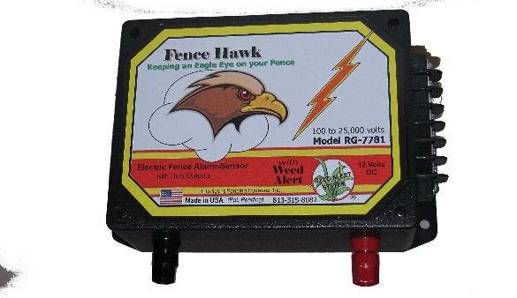*Features:*

* Weed growth alert
* Can distinguish between fence voltage and other voltage surges
* Intrusion Alert even without Fence energisation

**Design AIM:**

Electric Fence monitoring system with the following features:

* Remote turn ON and turn OFF
* Weed Alert
* System Monitoring and control via Smartphone
* System Status Update on request
* Periodic System Status Update
* Sudden Voltage Drop Alerts
* Overloading Alert

Constrains:

Design of the fence: depending on the terrain, materials and workers, different places have different types on fencing circuit employed. The device should be compatible with all the common designs out there.

Range of network in the area: the reliability of the device is questionable with respect to remote control and status update if the fence is located at areas where the network coverage is poor.

Power source: Reliable power source should be provided, since the device needs to be powered even when the fencing is turned OFF.

Unreliable earthing due to climatic condition: the proper working of the device depends upon the condition of the earthing provided, during summer, the ground gets dry and leads to improper earthing.

Calibration of the device: the device is to be calibrated upon first installation and every time the fence undergoes any changes or it may lead to unwanted triggering of alarm.

Syed merged